

CIS C290

M03 Assignment: Descriptive Analyses

Part 1. Using the data_science_salaries.csv file, run descriptive statistics on the data science salary data by experience level and write 3-4 sentences describing the data results. Include a screenshot of the Python output.

The dataset suggests that many data science professionals are at senior level, making up more than half of the sample. On the other hand, the executive level makes up the least number of people with only 228 out of 5827. Based on the salary’s descriptive analysis, there seems to be outliers with the max salary of $750k when the mean is only $155k, however further evaluations are required to say for certain. With such high standard of deviation level ($68k), the industry’s salary level is significantly dependent on the experience level of data scientists.

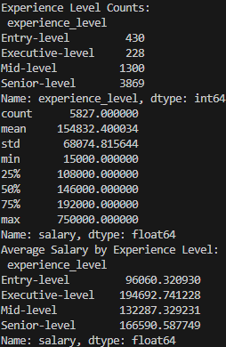

Part 2. Using the data_science_salaries.csv file, run counts on employment type and company size and report the data in a bar graph. Write 1-2 sentences describing the data results.

Based on the table and graph below, it is clear that the full-time employment type dominated the sample regardless of the company size. Which in turn indicates the salary and experience level from the previous section has little to no dependence on the company size and employment type.
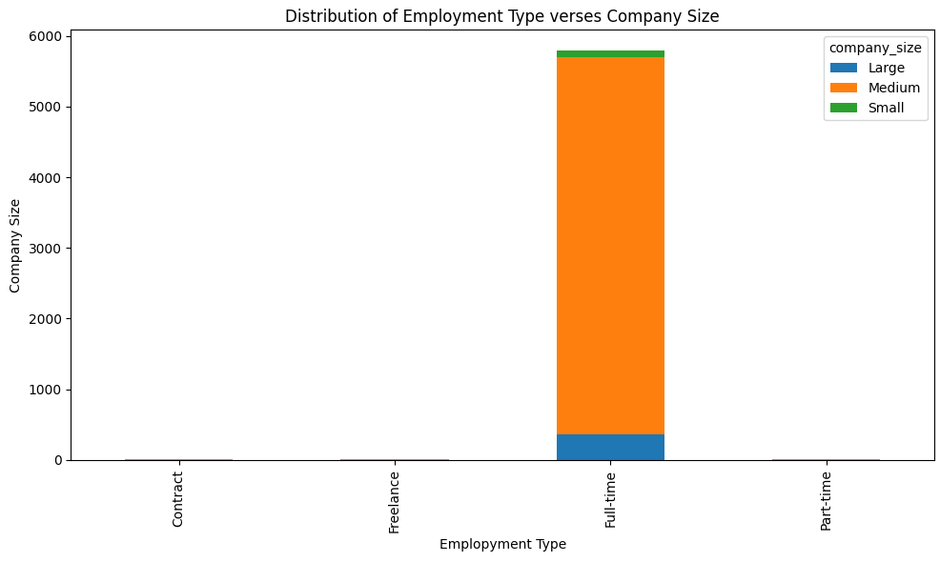

Part 3. Using the data_science_salaries.csv file, create a table that is the average salary by experience level and include the data summary in a formatted table. Write 1-2 sentences describing the data results.

Based on the table, the higher the experience level, which goes from lowest to highest as entry, mid, senior, then executive, the higher the salary, ranging an average from $96k to $195k.
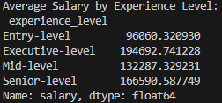

Part 4. In a minimum of 3 sentences, describe your experience with the assignment. Indicate which resources you used.

Throughout this assignment, I had a constant struggle to communicate and convey the story that the data is suggesting. Therefore, I worked with bare minimal details throughout the assignment. Also, it was a struggle to work with pandas as I have not used the library before.

